

Modern College of Arts, Commerce and Science,

Shivajinagar, Pune 09

Department of Statistics

PREDICTION AND ESTIMATION OF RAINFALL THROUGH VARIOUS STATISTICAL APPROACHES

19ScStaP306 Statistics Project



PROJECT REPORT ON:

PREDICTION AND ESTIMATION OF RAINFALL THROUGH VARIOUS STATISTICAL APPROACHES

BY

VISHAL JADHAV (2334352)

ANIKET UMRATKAR (2334321)

KUNAL HINGE (2334357)

STUDENTS OF

M.Sc. STATISTICS

MODERN COLLEGE, PUNE

UNDER THE GUIDENCE OF

Mrs. SONALI KULKARNI

(DEPARTMENT OF STATISTICS)

**CERTIFICATE**

This is to certify that the project work entitled “PREDICTION AND ESTIMATION OF RAINFALL THROUGH VARIOUS STATISTICAL APPROACHES” is a bonafide project work carried out by-

1) Mr. Vishal P. Jadhav

2) Mr. Aniket A. Umratkar

3) Mr. Kunal K. Hinge

the students of M.Sc.(Statistics) Part-II, Modern College Of Arts, Science and Commerce, Pune.

This original work is submitted for the partial fulfillment of M.Sc. degree for academic year 2023-24 as per the curriculum requirement laid down by Savitribai Phule Pune University, Pune.

Internal Examiner External Examiner Dr. Manisha Sane

(HoD) Statistics

Mrs. Sonali Kulkarni

Project Guide

Date:

Place: Modern College , Pune.

**ACKNOWLEDGEMENT**

Words on a paper a mere ink marks but when they have a purpose there exist a thought behind them. We too have a purpose to express our gratitude towards those individuals without whose guidance the project would not have been its successful termination.

We would like to express our sincere thanks to Prof. Dr. Manisha Sane ma’am, Head of Dept., Statistic, Mrs. Trupti Choudhary and our project guide Mrs. Sonali Kulkarni without whose guidance it would have been impossible to undertake this project and it was she who has given us the correct guidance and direction.

With deepest gratitude and respect, we acknowledge all the staff members of Statistics department of Modern College of Arts, Science and Commerce, for their valuable suggestions and for providing the necessary information required for this project and also thanks to those who are directly and indirectly involved in this project.

**DECLARATION BY THE STUDENTS**

We declare that the project entitled- “PREDICTION AND ESTIMATION OF RAINFALL THROUGH VARIOUS STATISTICAL APPROACHES”, submitted by us for the partial fulfillment of our master’s degree of Science in Statistics during 2023-24 is original work.

We further declare that the analysis has been carried out based on the primary data collected from imagebytes.in(website) and Internet.

1) Mr. Vishal P. Jadhav

2) Mr. Aniket A. Umratkar

3) Mr. Kunal K. Hinge

.

**Date:**

**Place:** Modern College, Pune-30.

**INDEX**

|  |  |  |
| --- | --- | --- |
| **Sr.**  **No.** | **CONTENT** | **Page**  **No** |
| 1. | CERTIFICATE | 3 |
| 2. | ACKNOWLEDGEMENT | 4 |
| 3. | ABSTRACT | 7 |
| 4. | MOTIVATION | 8 |
| 5. | INTRODUCTION | 9 |
| 6. | OBJECTIVES | 10 |
| 7. | METHODOLGY | 11 |
| 8. | DATA DESCRIPTION | 13 |
| 9. | THEROTICAL BACKGROUND | 14 |
| 10. | STATISTICAL ANALYSIS | 21 |
| 11. | MODEL BUILDING | 28 |
| 12. | STOCHASTIC APPROACH | 68 |
| 13. | CONCLUSION | 70 |
| 14. | LIMITATION AND SCOPE | 71 |
| 15. | REFRENCES | 73 |

**ABSTRACT**

Weather and rainfall play a vital role in every human life. Agriculture, Horticulture, and goods transportation are mainly depending upon rainfall, which comes under the goods and supply chain process. If that chain can break at any point, then ultimately the farmer will get losses. Therefore, timely prediction of rainfall is very much helpful to the farmers.

The statistical and machine learning models, driven by atmospheric synoptic trends generate long-term daily rainfall predictions. Whereas the proposed algorithms in the present research work predict rainfall on a daily and monthly basis, by using machine learning algorithms and evaluating the performance of models with suitable metrics. An anticipated idea in the research work is to execute correlation analysis in deriving the performance indicators, are required to evaluate the rainfall prediction model. This is important that the quality input leads to quality results. The data preprocessing techniques such as Principal Components Analysis (PCA), Independent Component Analysis (ICA), and Linear Discriminant Analysis (LDA) are used to make the data qualitative. The experimental results proved that; the proposed model succeeded in attaining good accuracy by using a moderate set of computing resources in generating rainfall predictions. In the approach, we developed a model to efficiently predict the rainfall, based on different metrices such as root mean squared error(RMSE), R-squared, Mean Absolute Error(MAE). All the proposed models outperformed when compared to existing rainfall prediction models.

**MOTIVATION**

Rainfall prediction is a crucial aspect of meteorology with significant implications for various sectors such as agriculture, water resource management, disaster preparedness, and more. Here are several motivations for rainfall prediction:

1. **Agriculture:** Farmers rely on accurate rainfall predictions to plan their planting and harvesting schedules. Adequate water supply is essential for crop growth, and knowing when to expect rainfall helps farmers optimize irrigation and crop management practices.
2. **Water Resource Management:** Precise rainfall predictions are vital for managing water resources. Reservoirs, dams, and other water storage facilities depend on accurate forecasts to plan for water availability and distribution. This is crucial for ensuring a stable water supply for both urban and rural areas.
3. **Disaster Preparedness and Response:** Timely and accurate rainfall predictions are essential for disaster preparedness and response. This is especially important in regions prone to extreme weather events such as hurricanes, typhoons, or monsoons. Early warnings based on rainfall predictions can save lives and minimize the impact of natural disasters.
4. **Climate Change Monitoring:** Understanding and predicting rainfall patterns contribute to monitoring and studying climate change. Changes in precipitation patterns over time can provide valuable insights into climate trends, helping researchers and policymakers develop strategies to mitigate the impacts of climate change.
5. **Hydroelectric Power Generation:** Hydroelectric power plants depend on water availability, which is influenced by rainfall. Accurate predictions enable power operators to anticipate changes in water levels and adjust energy production accordingly.

In summary, accurate rainfall predictions play a pivotal role in numerous aspects of society, influencing economic activities, environmental management, and public safety. Advances in forecasting technologies contribute to the overall well-being and sustainable development of communities around the world.

**INTRODUCTION**

Rainfall prediction plays a crucial role in various sectors, ranging from agriculture and water resource management to disaster preparedness. Accurate and timely forecasts empower communities and decision-makers to plan effectively, mitigating the impact of extreme weather events. Traditional methods of predicting rainfall often rely on historical data and meteorological models, but advancements in machine learning offer a promising avenue to enhance the precision of these predictions.

This project aims to leverage machine learning algorithms to improve the accuracy of rainfall prediction. By assimilating a diverse set of data sources, including meteorological variables, satellite imagery, and historical weather patterns, we seek to develop a robust model capable of forecasting rainfall with greater precision and lead time. The integration of machine learning techniques allows for the identification of complex patterns and relationships within the data, enabling more reliable predictions compared to conventional methods.

In this endeavour, we will explore various statistical tools and machine learning algorithms, such as decision trees to identify the most effective approach for rainfall prediction in our target region. The project will also involve feature engineering, data preprocessing, and model evaluation to ensure the reliability and generalizability of the developed predictive model.

The outcomes of this research have the potential to revolutionize current practices in rainfall prediction, providing actionable insights for agricultural planning, water resource management, and disaster response. Moreover, the project contributes to the growing field of applied machine learning for weather forecasting, showcasing the interdisciplinary synergy between meteorology and advanced data science.

As we delve into this exciting exploration at the intersection of meteorology and machine learning, we anticipate that our findings will not only advance the field but also contribute valuable tools for communities and organizations to adapt to the challenges posed by dynamic weather patterns and climate change.

**OBJECTIVES**

Creating clear and measurable objectives is crucial for the success of any project, including a rainfall prediction project. Here are some potential objectives for a rainfall prediction project:

1. **Model Building:**
   * Develop models that can provide accurate rainfall predictions for specific regions or localities, addressing the unique meteorological characteristics of those areas.
2. **Stochastic Approach:**
   * Extend the stochastic approach to long-term predictions, considering inter-annual variability and climate trends in addition to short-term variations.
3. **Water Resource Management:**

* To collaborate with meteorological agencies to enhance the effectiveness of the model and enable power operators to anticipate changes in water levels and adjust energy production accordingly.

1. **Individual Effects:**

* **To study the effect of dependent variables on independent variables control the extraneous factors.**

**METHODOLOGY**

Predicting rainfall involves a combination of meteorological, statistical, and machine learning techniques. Here's a general methodology you can follow for a rainfall prediction project:

1. **Define Objectives and Scope:**
   * Clearly define the objectives of your rainfall prediction project. Are you aiming for short-term or long-term predictions? Localized or regional predictions?
2. **Data Collection:**
   * Gather historical weather data, including rainfall, temperature, humidity, wind speed, and other relevant parameters. The more granular and accurate your data, the better your predictions will be.
   * Obtain satellite imagery, if available, for the region of interest.
   * Consider including geographical features like topography and land use data.
3. **Data Cleaning and Preprocessing:**
   * Handle missing data, outliers, and inconsistencies.
   * Convert timestamps into a usable format.
   * Normalize or standardize numerical data.
   * Explore relationships between different variables through exploratory data analysis (EDA).
4. **Feature Selection:**
   * Identify the most relevant features for rainfall prediction.
   * Consider using domain knowledge and statistical methods for feature selection.
5. **Data Splitting:**
   * Split your dataset into training, validation, and test sets. The training set is used to train the model, the validation set helps in tuning hyperparameters, and the test set evaluates the model's performance.
6. **Model Selection:**
   * Choose appropriate models for rainfall prediction. Common choices include:
     + Time series models (ARIMA, SARIMA) for temporal patterns.
     + Regression models (linear regression, decision trees) for simple relationships.
     + Machine learning models (random forests, gradient boosting, neural networks) for complex patterns.
7. **Model Training:**
   * Train your selected model using the training dataset.
   * Fine-tune hyperparameters using the validation set.
8. **Model Evaluation:**
   * Evaluate the model's performance on the test set using appropriate metrics (e.g., mean absolute error, root mean squared error).
9. **Model Interpretation:**
   * Understand the factors contributing to the model's predictions.
   * Visualize important features and relationships.
10. **Deployment:**
    * Deploy the trained model in a suitable environment for making real-time predictions.

Remember that the success of a rainfall prediction project depends on the quality and quantity of data, the appropriateness of the chosen model, and the ongoing maintenance and improvement of the system. Keep an eye on advancements in meteorology and machine learning to enhance your predictions over time.

**DATA DESCRIPTION**

* **In order to develop a robust and accurate rainfall prediction model, a comprehensive data collection effort is underway, encompassing a diverse range of meteorological variables such as temperature, humidity, wind patterns, and historical precipitation data from an extensive network of weather stations spanning the target region.**
* **The data has been obtained from the nasa’s earth science project.**

**The data comprises of observations on 11 variables for the years 2016 to 2022.**

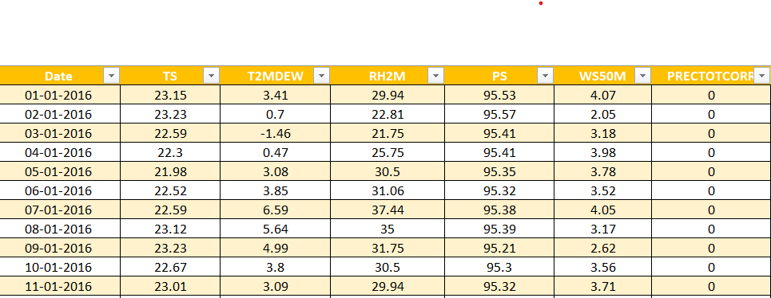

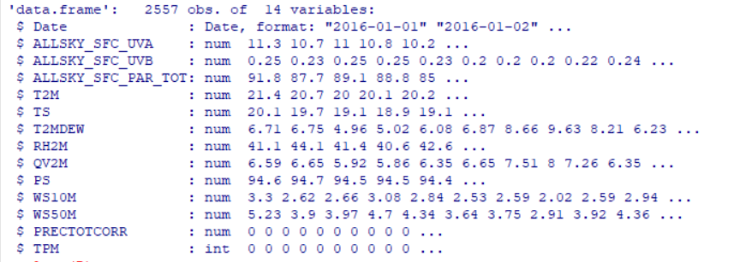

**THEROTICAL BACKGROUND**

1. **Multiple Linear Regression**

Multiple linear regression is a statistical method used to model the relationship between two or more independent variables and a dependent variable. The goal is to find the best-fitting linear equation that predicts the values of the dependent variable based on the values of the independent variables.

Here's a concise overview:

1. **Variables:**
   * Dependent Variable (Y): The variable you want to predict.
   * Independent Variables (X₁, X₂, ..., Xₙ): The variables that are used to predict the dependent variable.
2. **Equation:** The multiple linear regression equation looks like this:

*Y*=*β*0​+*β*1​*X*1​+*β*2​*X*2​+…+*βn*​*Xn*​+*ε*

* + *Y* is the dependent variable.
  + *X*1​,*X*2​,…,*Xn*​ are independent variables.
  + *β*0​,*β*1​,*β*2​,…,*βn*​ are the coefficients representing the strength and direction of the relationship.
  + *ε* is the error term representing unexplained variation.

1. **Objective:** Find the values of *β*0​,*β*1​,*β*2​,…,*βn*​ that minimize the difference between the predicted values and the actual values of the dependent variable.
2. **Assumptions:**
   * Linearity: The relationship between variables is linear.
   * Independence: Observations are independent.
   * Homoscedasticity: The variance of the errors is constant.
   * Normality: The errors are normally distributed.
3. **Interpretation:**
   * *β*0​ is the intercept, representing the predicted value of *Y* when all independent variables are zero.
   * *β*1​,*β*2​,…,*βn*​ represent the change in *Y* for a one-unit change in the corresponding independent variable, holding other variables constant.
4. **Evaluation:**
   * Use statistical metrics like R-squared, p-values, and others to assess the goodness of fit and significance of the coefficients.

Multiple linear regression is widely used in various fields, including economics, finance, biology, and social sciences, to analyse and predict relationships between variables.

1. **Polynomial Regression**
2. Polynomial regression is a type of regression analysis where the relationship between the independent variable (input) and the dependent variable (output) is modeled as an nth-degree polynomial. In simpler terms, it involves fitting a curve to the data points using a polynomial equation. This allows for capturing more complex relationships than linear regression, which uses a straight line.
3. The polynomial regression equation looks like this:

*y*=*b*0​+*b*1​⋅*x*+*b*2​⋅*x*2+…+*bn*​⋅*xn*

1. Here, *y* is the dependent variable, *x* is the independent variable, and *n* is the degree of the polynomial. The coefficients *b*0​,*b*1​,…,*bn*​ are determined through the regression analysis, and they represent the weights assigned to the different powers of *x* in the polynomial equation.
2. Polynomial regression is useful when the relationship between variables is not linear and can help capture more intricate patterns in the data. However, higher-degree polynomials can lead to overfitting, so the choice of the degree should be carefully considered based on the specific dataset and problem at hand.
3. **ARIMA**

ARIMA (AutoRegressive Integrated Moving Average) and SARIMA (Seasonal Auto Regressive Integrated Moving Average) are statistical models used for time series forecasting. Here's a brief overview of each:

1. **ARIMA (AutoRegressive Integrated Moving Average):**
   * **AutoRegressive (AR):** This component captures the relationship between the current observation and its past observations. It involves regressing the current value on its own lagged values.
   * **Integrated (I):** This component accounts for the differencing needed to make the time series stationary. Stationarity is important for modeling time series data.
   * **Moving Average (MA):** This component incorporates the dependency between the current observation and a residual error from a moving average model applied to lagged observations.

The ARIMA model is denoted as ARIMA(p, d, q), where:

* + p is the order of the AR (AutoRegressive) component,
  + d is the order of differencing,
  + q is the order of the MA (Moving Average) component.

1. **SARIMA (Seasonal AutoRegressive Integrated Moving Average):**
   * SARIMA extends ARIMA to account for seasonality in time series data.
   * It introduces additional seasonal components, including Seasonal AutoRegressive (SAR), Seasonal Integrated (I), and Seasonal Moving Average (SMA) terms.

The SARIMA model is denoted as SARIMA(p, d, q)(P, D, Q, s), where:

* + (p, d, q) are the non-seasonal components, as in ARIMA.
  + (P, D, Q) are the seasonal components, analogous to (p, d, q), but for the seasonal part.
  + s is the length of the seasonality (e.g., 12 for monthly data with a yearly seasonality).

In summary, ARIMA is a general time series forecasting model, while SARIMA extends it to handle seasonality in the data. Choosing the right orders (p, d, q, P, D, Q) for these models often involves statistical analysis, such as examining autocorrelation and partial autocorrelation plots, and tuning the parameters based on the specific characteristics of the time series data.

1. **Logistic Regression**

Logistic regression is a statistical method used for binary classification problems, where the outcome variable is categorical with two possible classes. It's a type of regression analysis that models the probability of the dependent variable belonging to a particular category.

In logistic regression:

1. **Input Features:** It takes one or more independent variables (features) as input.
2. **Output:** The output is transformed using the logistic function (sigmoid) to ensure that the predicted values lie between 0 and 1, representing probabilities.
3. **Model Training:** The model is trained by optimizing the coefficients of the input features to maximize the likelihood of the observed outcomes.
4. **Decision Boundary:** A decision boundary is established, which separates the classes based on the calculated probabilities. Commonly, if the probability is greater than 0.5, the instance is predicted to belong to one class; otherwise, it's predicted to belong to the other class.

Logistic regression is widely used in various fields, such as finance, healthcare, and social sciences, for tasks like spam detection, disease prediction, and customer churn analysis. It's a simple yet effective algorithm for binary classification problems.

1. **CART**

CART, which stands for Classification and Regression Trees, is a popular machine learning algorithm used for both classification and regression tasks. It was developed by Leo Breiman in 1986. CART builds binary trees by recursively partitioning the data into subsets based on the values of input features. Here are some key points about CART:

1. **Tree Structure:**
   * CART constructs a binary tree where each node represents a decision based on a specific feature and a threshold.
   * The tree is grown recursively by splitting nodes into child nodes until a stopping criterion is met.
2. **Node Splitting:**
   * At each node, the algorithm selects the feature and threshold that optimally divides the data into two subsets.
   * The splitting process aims to maximize the homogeneity (purity) of the target variable within each subset.
3. **Objective Function:**
   * For classification tasks, CART typically uses measures like Gini impurity or entropy to evaluate the quality of a split. The algorithm chooses the split that minimizes impurity.
   * For regression tasks, CART uses mean squared error (MSE) as the criterion to minimize when making split decisions.
4. **Stopping Criteria:**
   * The tree-growing process continues until a predefined stopping criterion is met. Common criteria include a maximum tree depth, a minimum number of samples in a leaf node, or a minimum improvement in impurity.
5. **Pruning:**
   * After the tree is grown, it may be pruned to prevent overfitting. Pruning involves removing nodes that do not significantly contribute to the model's predictive performance.
6. **Handling Categorical Variables:**
   * CART can handle both numerical and categorical features. For categorical features, it performs binary splits based on category membership.
7. **Prediction:**
   * For a given input, the algorithm traverses the tree from the root to a leaf node, and the prediction is made based on the majority class (for classification) or the mean value (for regression) in the leaf node.
8. **Advantages:**
   * CART is relatively easy to understand and interpret.
   * It can handle a mix of categorical and numerical features.
   * It doesn't require extensive data preprocessing.
9. **Disadvantages:**
   * Prone to overfitting, especially if the tree is allowed to grow too deep.
   * Can be sensitive to small variations in the data.
   * May not perform well when the relationships between features and the target variable are complex.

CART is the foundation for ensemble learning methods like Random Forests and Gradient Boosted Trees, which aim to improve predictive performance and address some of the limitations of individual decision trees.

1. **Random Forest**

Random Forest is a popular machine learning algorithm that belongs to the ensemble learning category. It is an ensemble of decision trees, where each tree is trained on a different subset of the training data, and the final prediction is a combination of the predictions from all the individual trees.

Here are the key components and steps involved in building and using a Random Forest:

1. **Decision Trees:**
   * Random Forest is an ensemble of decision trees. Decision trees are simple, tree-like structures that make decisions based on features of the input data.
   * Each decision tree in a Random Forest is constructed by selecting a random subset of the training data and a random subset of features for each split.
2. **Bootstrapping:**
   * Random Forest uses a technique called bootstrapping, where multiple subsets of the training data are created by random sampling with replacement. This means that some samples may be repeated in a subset, while others may be left out.
3. **Random Feature Selection:**
   * At each node of a decision tree, a random subset of features is considered for splitting. This adds an element of randomness and diversity to the individual trees.
4. **Building Trees:**
   * Each decision tree is constructed using the bootstrapped subset of data and the randomly selected features. The trees are grown deep, typically until a certain depth or until they cannot be further split.
5. **Voting/Averaging:**
   * For classification tasks, the final prediction is made by a majority vote of the individual tree predictions. For regression tasks, the final prediction is often the average of the individual tree predictions.
6. **Hyperparameter Tuning:**
   * Random Forest has hyperparameters that can be tuned for optimal performance. These include the number of trees in the forest, the maximum depth of each tree, and the minimum number of samples required to split a node, among others.
7. **Out-of-Bag (OOB) Error:**
   * Since each tree is trained on a different subset of data, some data points are not used in the training of specific trees. The out-of-bag error is an estimate of the model's performance on unseen data and is computed using the data points not included in the training of each tree.

Random Forests are widely used in practice due to their ability to handle complex datasets, provide good generalization, and resist overfitting. They are applicable to both classification and regression tasks. Additionally, they can handle missing values and maintain good performance even with a large number of features.Top of Form

1. **Stepwise selection method**

Stepwise selection is a method used in statistical modeling to identify a subset of variables for a predictive model. It involves iteratively adding or removing variables based on certain criteria. There are two main types of stepwise selection: forward selection and backward elimination.

1. **Forward Selection:**
   * Start with an empty model.
   * Iteratively add variables one at a time.
   * Select the variable that provides the best improvement in model fit.
   * Repeat until a stopping criterion is met (e.g., no more significant variables can be added).
2. **Backward Elimination:**
   * Start with a model that includes all variables.
   * Iteratively remove variables one at a time.
   * Remove the variable that provides the least contribution to the model fit.
   * Repeat until a stopping criterion is met (e.g., all remaining variables are significant).
3. **Stepwise Selection:**
   * Combines forward selection and backward elimination.
   * Start with an empty or full model.
   * Iteratively add or remove variables based on statistical criteria.
   * Repeat until the model's performance meets a predetermined threshold or no further improvement is possible.

Stepwise selection is a common technique for variable selection in regression analysis, where the goal is to build a model that explains the relationship between the independent variables and the dependent variable. However, caution is advised when using stepwise selection, as it may lead to overfitting or selecting variables based on chance. It's important to validate the selected model using techniques like cross-validation. Additionally, alternative variable selection methods, such as regularization techniques (e.g., LASSO, Ridge regression), are often recommended for more robust model building.

Top of Form

**STATISTICAL ANALYSIS**

**Preliminary Analysis**

1. **Pune Region (Khadakwasla Dam)**

**The basic correlation plot of the variables is shown below**



Multicollinearity is a statistical phenomenon where two or more independent variables in a regression model are highly correlated, making it difficult to isolate the individual effect of each variable on the dependent variable.

Here it is observed that we get pairs of variables which of them are highly correlated such as wind speed at 10M and wind speed at 50M.So we need to identify and remove multicollinearity from the data.

**Variable Selection**

To select the variables we used Stepwise selection method.

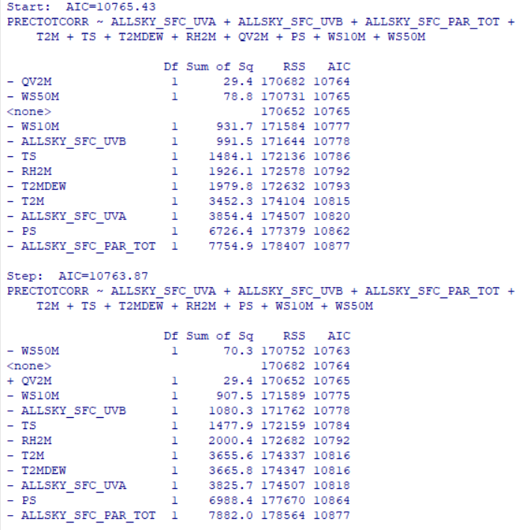

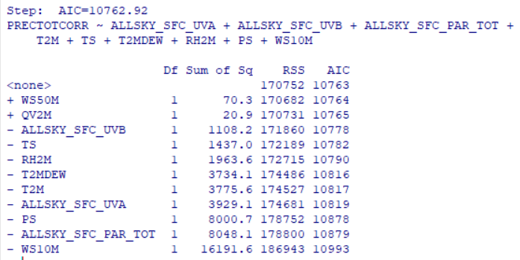

**We get the model by Stepwise selection as above. The variables which are not contributing significantly in the model are WS50M and QV2M.Hence we removed those variables from the data.**

**Taking in consideration the above results There are 3 ways to deal with multicollinearity we use deleting the variables. After deleting the variable we took in consideration the five important variables**

1. **Total Photosynthetically Active Radiations**
2. **Surface Temperature**
3. **Due Point Temperature**
4. **Surface Pressure**
5. **Wind Speed at 50 meters**

**Basic plot of variables against Date**

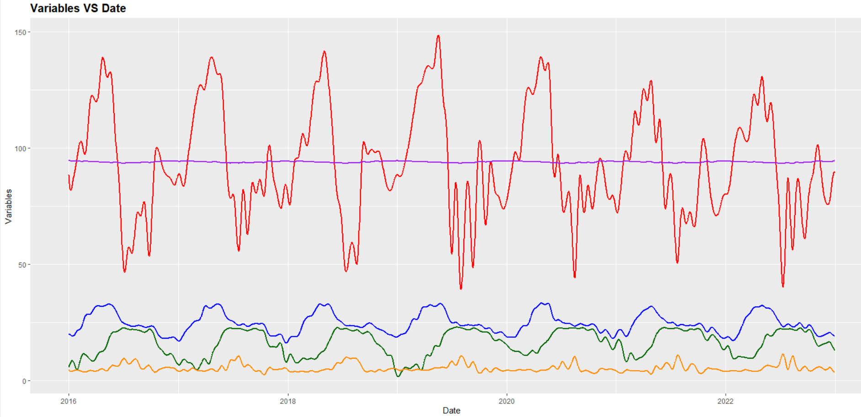

**The graph shows the basic line plot of all variables against date. It shows that the photosynthetically active radiations are more volatile whereas the surface pressure does not show much variation. The wind speed at 50 meters being less in unit is out performed by the remaining variables. The surface temperature and dew point temperature are showing identical pattern.**

**Individual effects of variables on Precipitation**

1. **Photosynthetically Active Radiation**



**The graph shows that as the radiations are increasing the precipitation goes on decreasing.**

1. **Surface Temperature**



**The graph shows that the precipitation varies within a specific range of Surface temperature.**

1. **Dew point Temperature**



**The graph suggests that the precipitation gets triggered at a particular value of dew point temperature.**

1. **Surface Pressure**



**There is a decrease in precipitation as the surface pressure goes on increasing.**

1. **Wind Speed at 50 Meters**



**The graphs shows that the precipitation increases as the wind speed at 50 meters increases.**

**Boxplot of Variables:-**



**The boxplot shows photosynthetically active radiations are more varying whereas the surface pressure is the least varying.**

**Summary of this five variable:-**

**The basic summary statistics of the included variables are as follows**

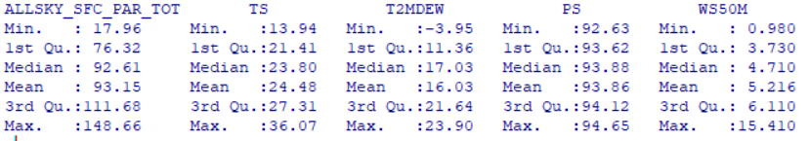

**Model Building**

1. **Multiple Linear Regression**

**The result of the fitted multiple linear model are as below**

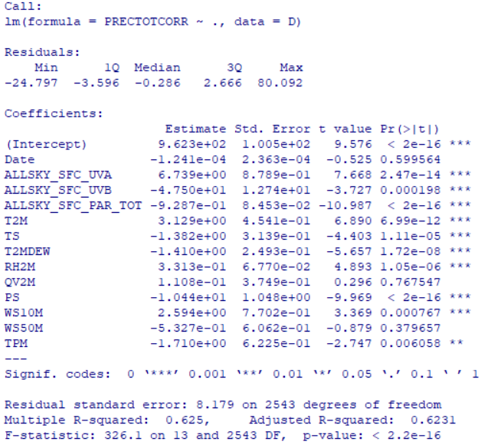

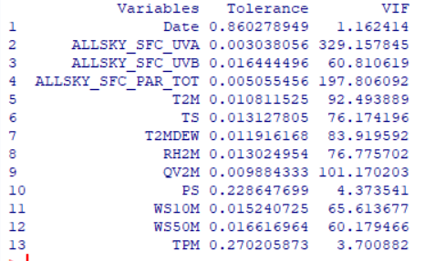

**Here the VIF values also confirmed that there was multicollinearity present in our data.**

**After removing multicollinearity and then fitting multiple linear regression we get the following results**

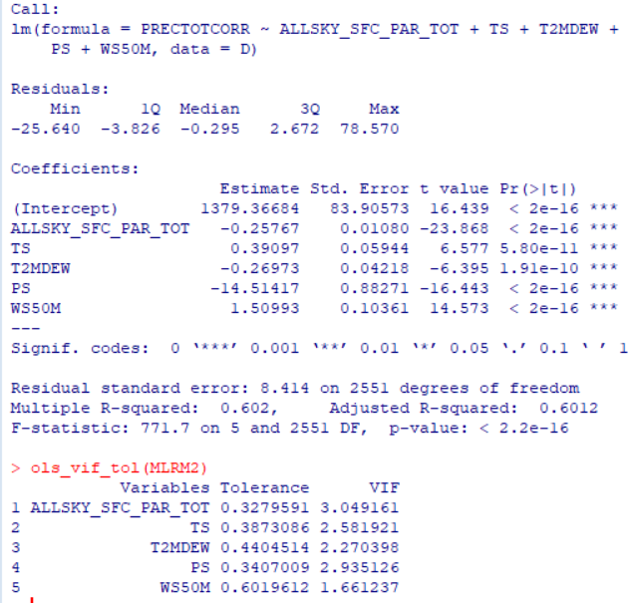

**The VIF values show that the multicollinearity has been removed and the further analysis can be carried out.**

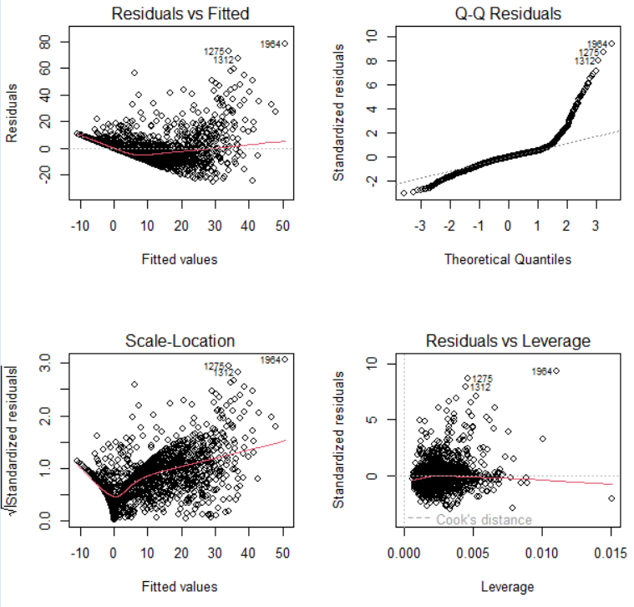

**The graph for the residuals Vs fits shows the outward opening funnel which tells us that there is a need to transform our decision variable. The suitable transformation in such case is square root transformation.**

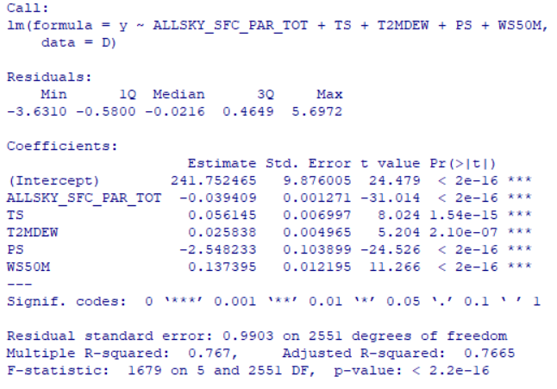

**The R squared value for the transformed data is 0.76 we try to improve this by doing further analysis.**

**Hence we then use polynomial regression.**

1. **Polynomial Regression**

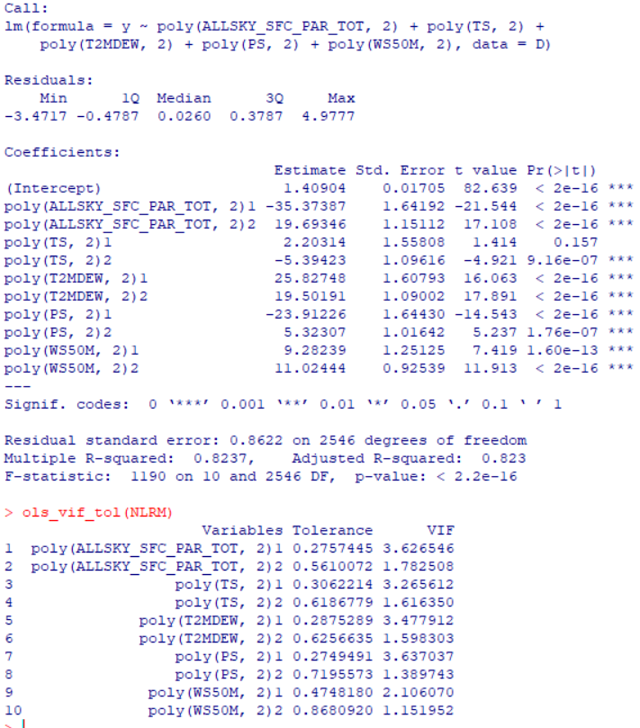

**Using polynomial regression The R squared value is observed to be 0.82**

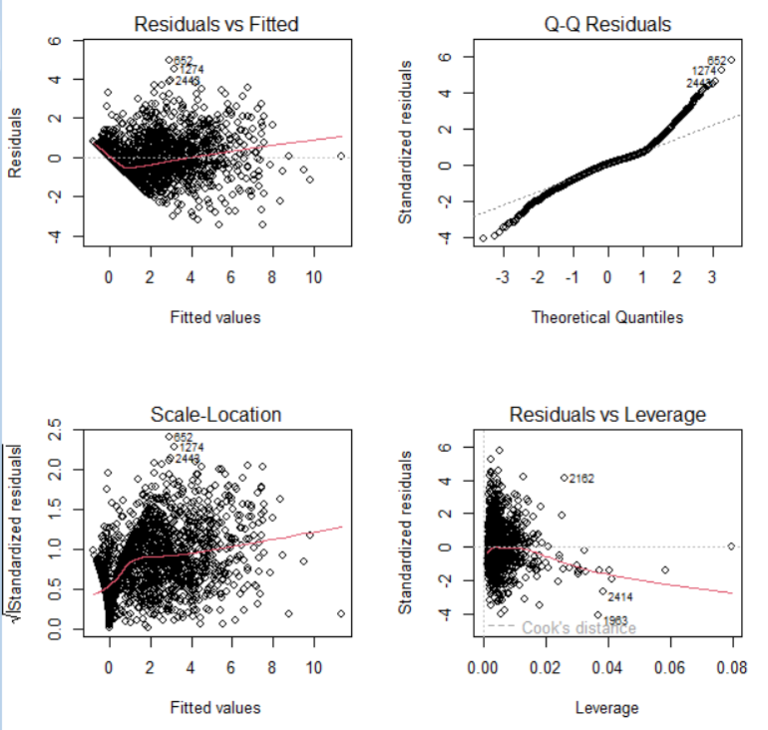

**Here the normal Q-Q plot shows that the residuals are not normally distributed so the model does not follow our required assumptions.**

1. **ARIMA**

**The data being time dependent we can use time series analysis for or data.**

**For ARIMA forecasting we converted our daily data to monthly data.**

**Boxplot of Precipitation**



**The boxplot suggest that the rainfall varies between June to October which mostly is considered as monsoon in Indian subcontinent region. This variability would help us to study the climates changing patterns.**

**Mainly there are four different methods in arima forecasting namely**

**1. Mean Method**

**2. Naïve Method**

**3. Drift Method**

**4. Seasonal Naïve Method**

**We used all these methods to forecast our series.**



**The above graph shows the forecast of the future two periods using different methods.**

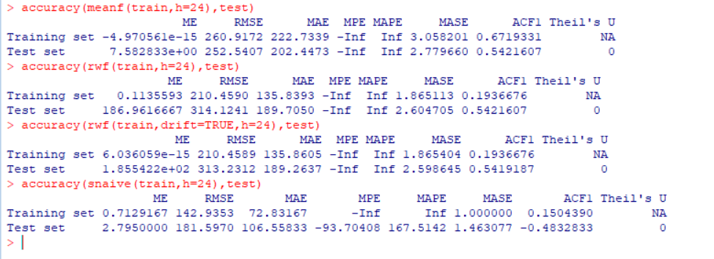

**The above are the accuracy measures for the forecasted values which suggest that the RMSE value is the least for the snaive method so we will use this for the forecasting for the fitted ARIMA model.**

**The Suitable ARIMA model for the data and the forecasted values for the next 2 years are as follows**

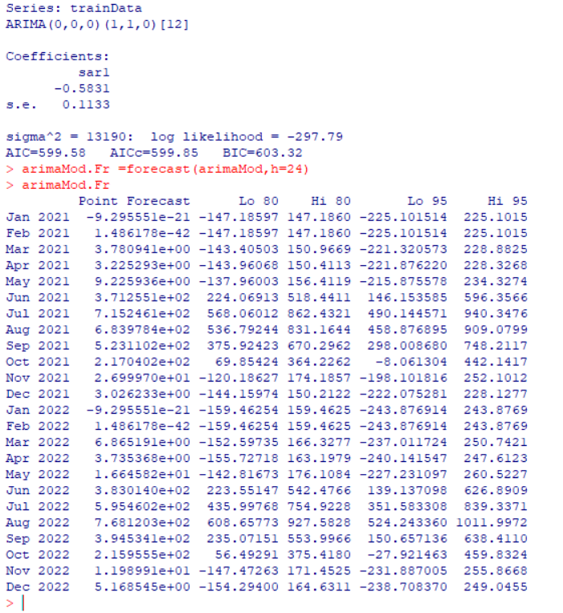

**The plot shows the forecast of the values along with the 80% and 95% confidence intervals for the forecasted values.**

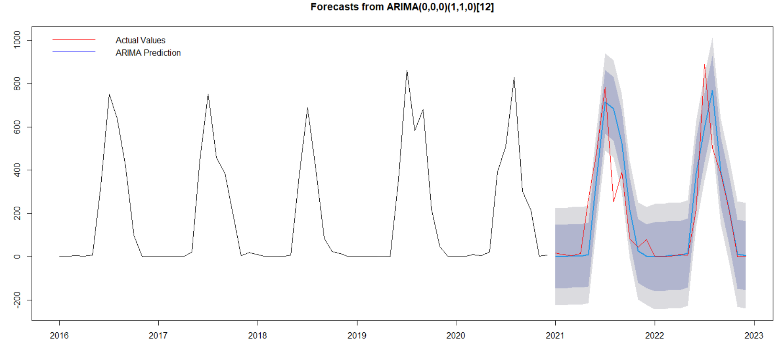

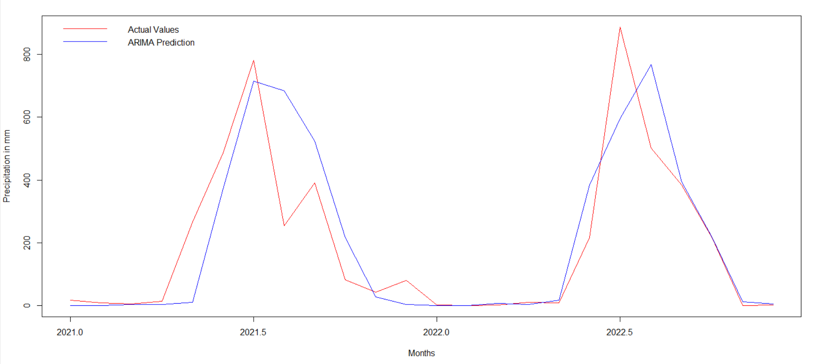

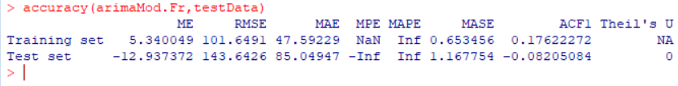

**The accuracy measures are as above which tells us that the test data RMSE value is close to train data RMSE value.**

**For this model we now check whether our assumptions are followed or not.**

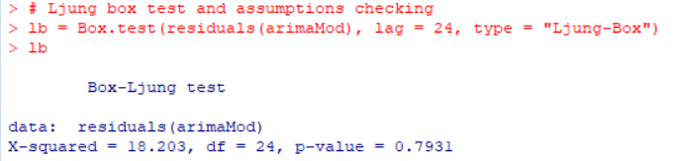



**Here the series is stationary and the normality assumptions are also followed thus the fitted model is appropriate for the data.**

1. **Logistic Regression**

**We Further proceed to Fit a logistic regression**

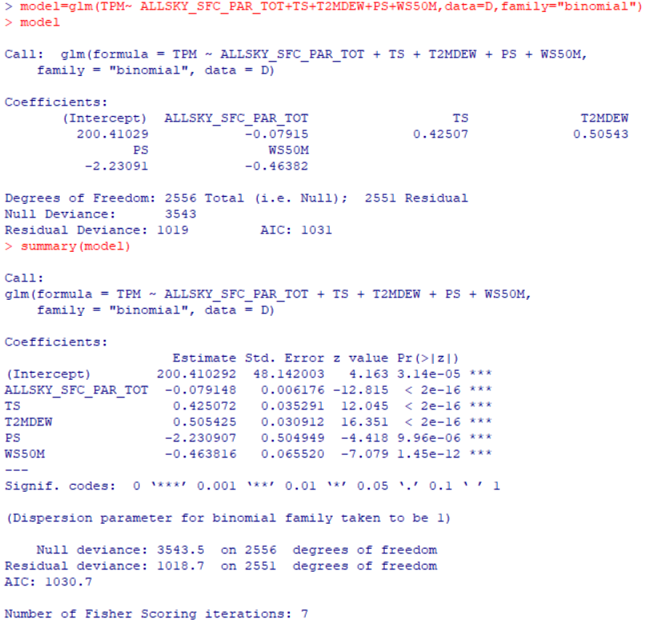



**The residual plot shows that the residuals are not normally distributed so we reject the hypothesis also based on the model deviance.**

1. **CART**

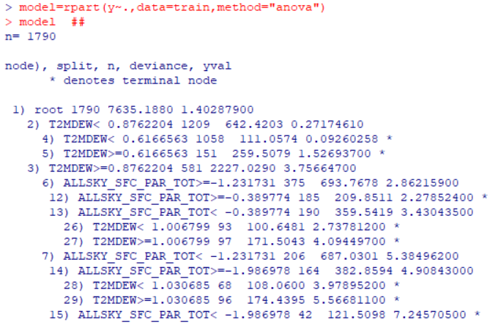

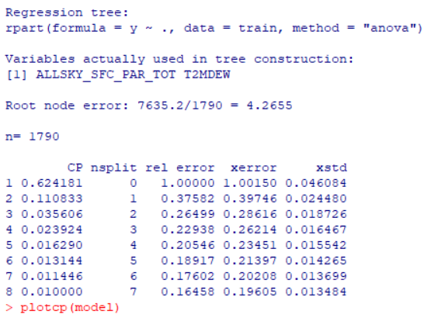



**Here we look for that value of the cp where the relative error is minimum.**

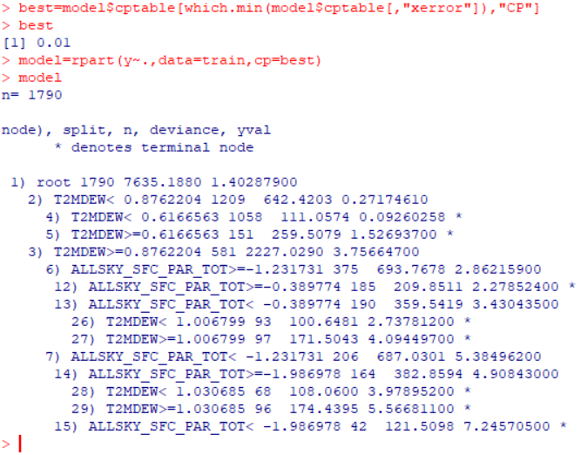

**Here the best CP was found to be 0.01 and hence we build a model around that CP and prune the tree.**



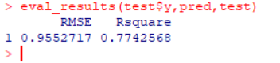

**Here the accuracy measures are taken into consideration. The RMSE value is less but we try to improve our R square more.**

1. **Random Forest**

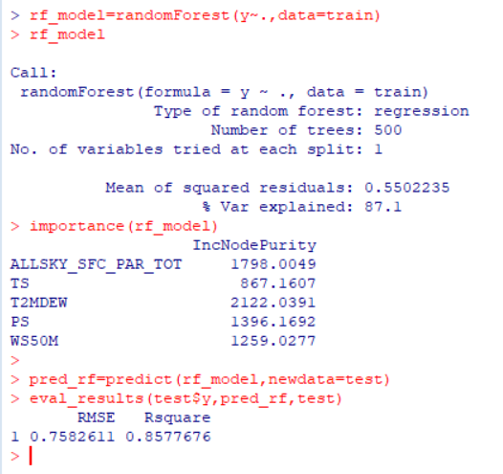



**Here using the random forest algorithm we see that the 87% of the variation is explained by the algorithm. Also we predicted the values and the RMSE value is observed to be less and R square value is also good so we stop here as we get the desired amount of results.**

**The Graph of Actual VS Predicted value**



1. **Solapur Region (Ujani Dam)**
   * 1. **Multiple Linear Regression**

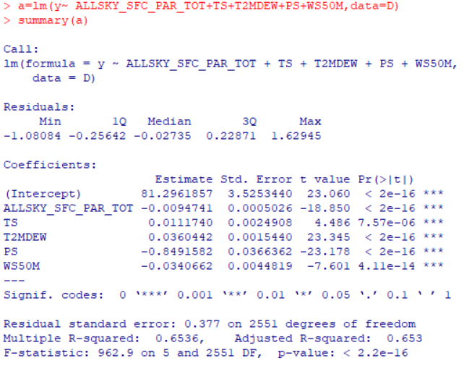

**The R squared value for the transformed data is 0.6536 we try to improve this by doing further analysis.**

* + 1. **Polynomial Regression**

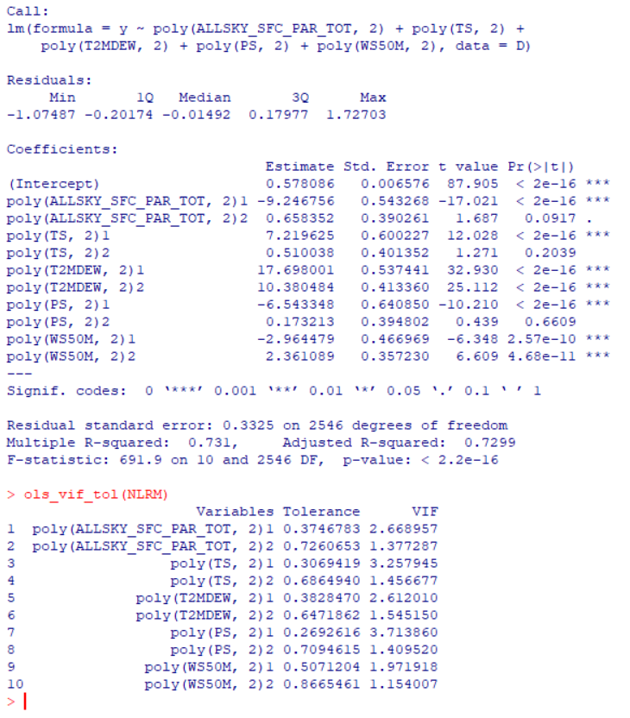

**The R squared value for the data is 0.73 we try to improve this by doing further analysis.**

* + 1. **ARIMA**



**The boxplot suggest that the rainfall varies between June to October which mostly is considered as monsoon in Indian subcontinent region. This variability would help us to study the climates changing patterns.**



**The above graph shows the forecast of the future two periods using different methods.**

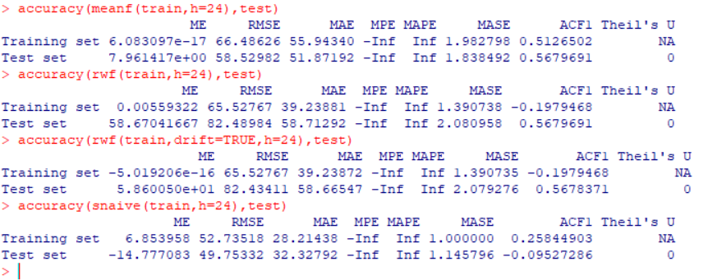

**The above are the accuracy measures for the forecasted values which suggest that the RMSE value is the least for the snaive method so we will use this for the forecasting for the fitted ARIMA model.**

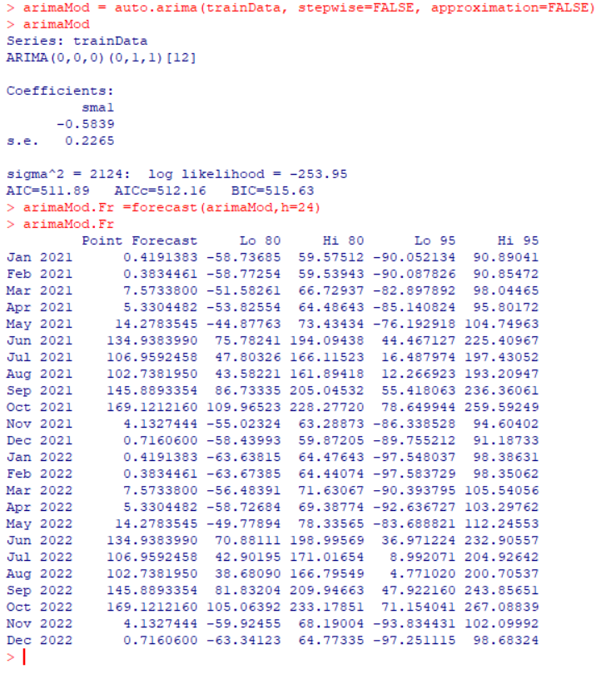



**The plot shows the forecast of the values along with the 80% and 95% confidence intervals for the forecasted values.**



**The accuracy measures are as above which tells us that the test data RMSE value is close to train data RMSE value.**



**Here the series is stationary and the normality assumptions are also followed thus the fitted model is appropriate for the data.**

* + 1. **Logistic Regression**

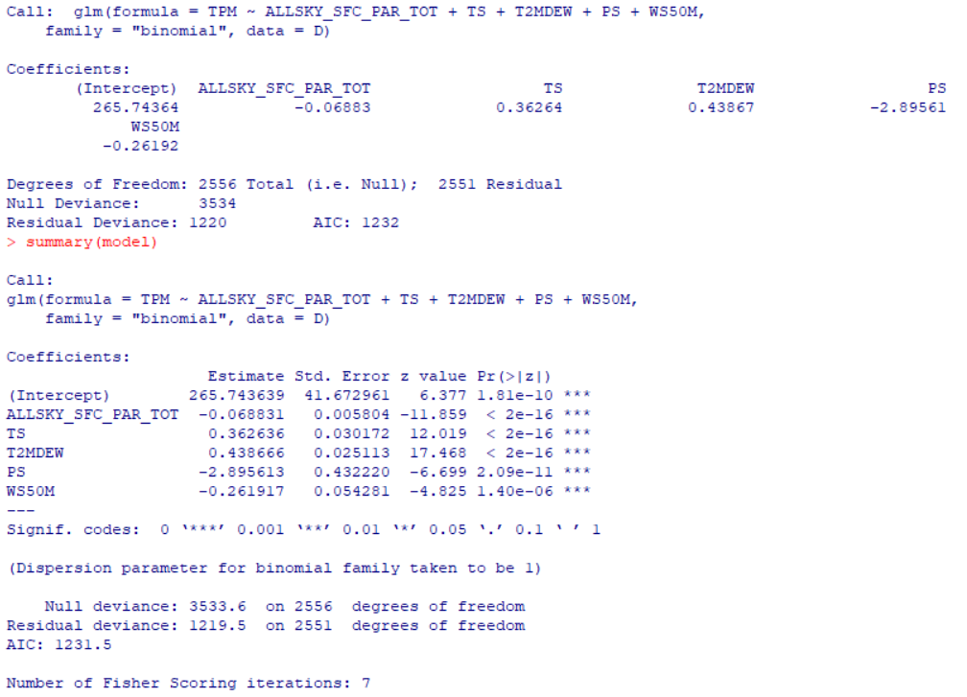



**The residual plot shows that the residuals are not normally distributed so we reject the hypothesis also based on the model deviance.**

* + 1. **CART**

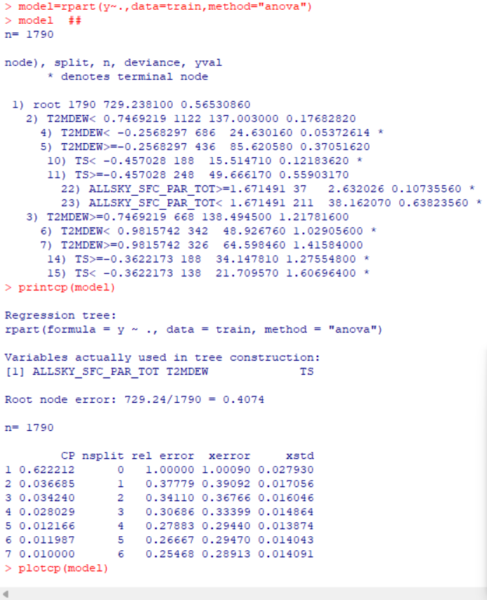



**Here we look for that value of the cp where the relative error is minimum.**

**Here the best CP was found to be 0.01 and hence we build a model around that CP and prune the tree.**

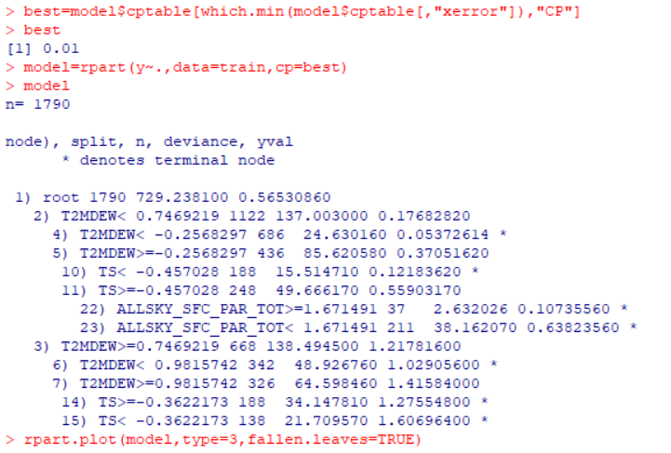



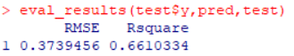

**Here the accuracy measures are taken into consideration. The RMSE value is less but we try to improve our R square more.**

* + 1. **Random forest**

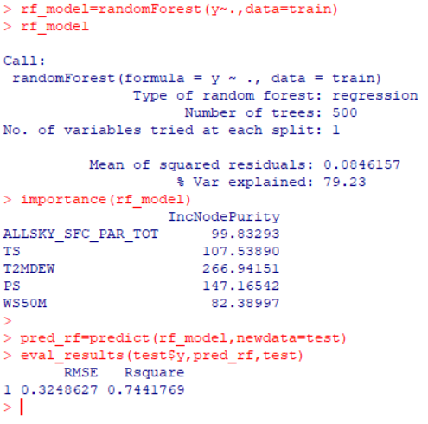



**Here using the random forest algorithm we see that the 79% of the variation is explained by the algorithm. Also we predicted the values and the RMSE value is observed to be less and R square value is also good so we stop here as we get the desired amount of results.**



1. **Sambhaji Nagar Region (Jayakwadi Dam)**
   * 1. **Multiple Linear Regression**

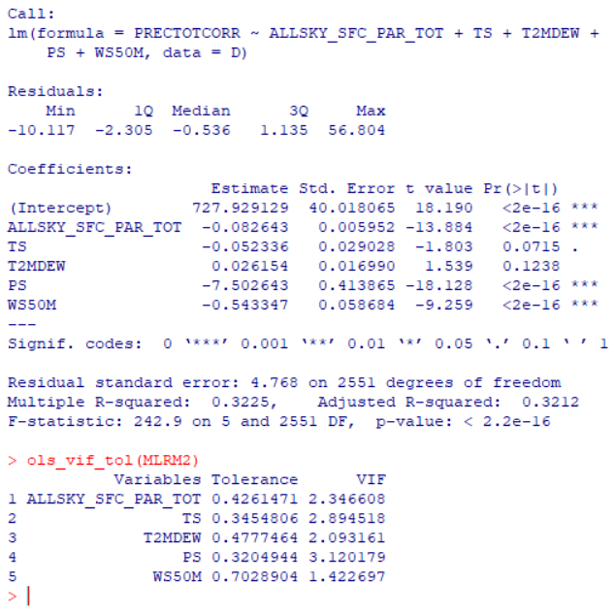

**The R squared value for the transformed data is 0.3225 we try to improve this by doing further analysis.**

* + 1. **Polynomial regression**

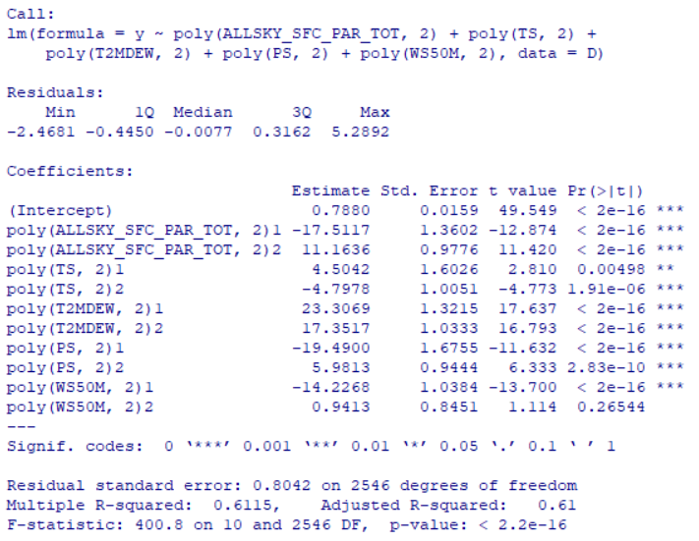

**The R squared value for the data is 0.6115 we try to improve this by doing further analysis.**

* + 1. **ARIMA**



**The boxplot suggest that the rainfall varies between June to October which mostly is considered as monsoon in Indian subcontinent region. This variability would help us to study the climates changing patterns.**

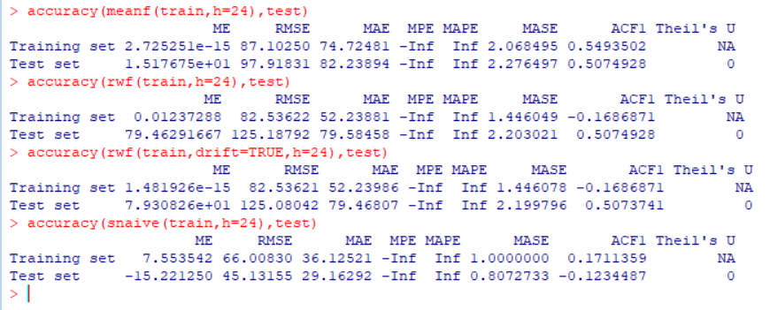

**The above are the accuracy measures for the forecasted values which suggest that the RMSE value is the least for the snaive method so we will use this for the forecasting for the fitted ARIMA model.**



**The plot shows the forecast of the values along with the 80% and 95% confidence intervals for the forecasted values.**



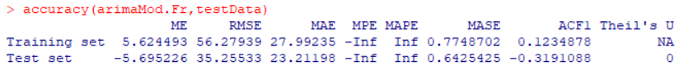

**The accuracy measures are as above which tells us that the test data RMSE value is close to train data RMSE value.**

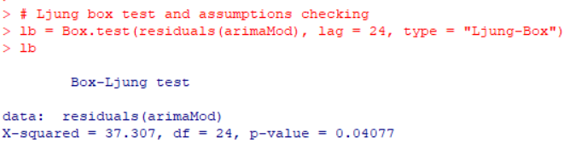



**Here the series is stationary and the normality assumptions are also followed thus the fitted model is appropriate for the data.**

* + 1. **CART**



**Here we look for that value of the cp where the relative error is minimum.**

**Here the best CP was found to be 0.01 and hence we build a model around that CP and prune the tree.**

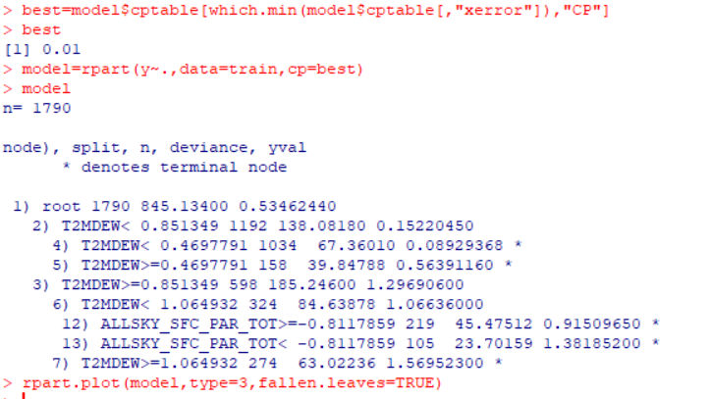



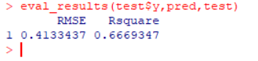

**Here the accuracy measures are taken into consideration. The RMSE value is less but we try to improve our R square more.**

* + 1. **Random Forest**



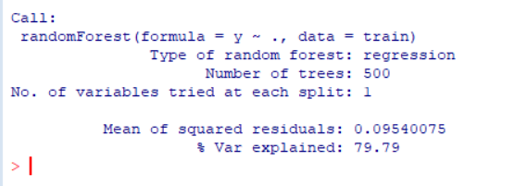

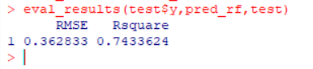

**Here using the random forest algorithm we see that the 80% of the variation is explained by the algorithm. Also we predicted the values and the RMSE value is observed to be less and R square value is also good so we stop here as we get the desired amount of results.**

**Plot of the Predicted values**



**STOCHASTIC APPLICATION**

Rainfall is inherently a stochastic process, influenced by various atmospheric and environmental factors. Traditional deterministic models may struggle to capture the inherent randomness and variability in precipitation patterns. Stochastic models, on the other hand, allow us to represent this variability, making them well-suited for studying dry and wet periods.

Understanding the distribution and characteristics of dry and wet days is crucial for water resource management, agriculture, and flood prediction. Stochastic models enable the analysis of these patterns over different temporal scales.

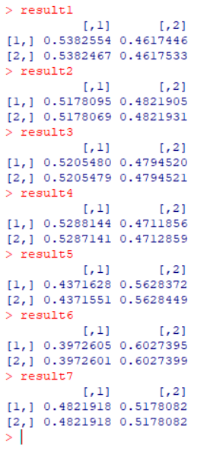

**The above are the nth step transition probability matrices of the count of dry days and wet days yearly. We tried to find the steady state distribution. Here the rows remain the same after the nth step, it indicates that the probabilities of transitioning from the initial state to other states have stabilized or reached a steady state. In other words, the system has reached an equilibrium where the probabilities of being in each state no longer change with additional time steps. Hence we can conclude that the rainfall is independently distributed irrespective of the year.**

**CONCLUSION**

In conclusion, the rainfall prediction project has demonstrated the potential to contribute significantly to our understanding of weather patterns and enhance our ability to forecast precipitation accurately. Through the utilization of advanced machine learning algorithms and data analysis techniques, we have developed a model that can predict rainfall patterns with a reasonable level of accuracy.

The project's success underscores the importance of leveraging technology to address complex environmental challenges. Accurate rainfall predictions are crucial for various sectors, including agriculture, water resource management, and disaster preparedness. The developed model can serve as a valuable tool for decision-makers, enabling them to make informed choices based on reliable forecasts.

However, it is essential to acknowledge the inherent uncertainties in weather prediction and the continuous need for improvement in model performance. Ongoing research and data refinement are necessary to enhance the accuracy and reliability of rainfall predictions. Collaboration with meteorological agencies, researchers, and data scientists will be crucial in refining and updating the model over time.

As technology advances and more data becomes available, there is potential for further refinement and expansion of the project. Continuous monitoring and evaluation will be essential to ensure that the model remains effective in different geographical regions and under various climate conditions.

In summary, the rainfall prediction project represents a significant step forward in harnessing the power of data and machine learning for weather forecasting. While the model's current performance is promising, it is just the beginning of a journey toward more accurate and reliable rainfall predictions, contributing to improved decision-making and preparedness in the face of changing weather patterns.

**LIMITATION AND SCOPE**

A rainfall prediction project, like any other predictive modeling endeavour, comes with its own set of limitations and scope considerations. Here are some general points to consider:

**Limitations:**

1. **Data Quality and Availability:**
   * Limited or poor-quality data can affect the accuracy of predictions. Incomplete or inaccurate historical rainfall data can hinder the model's ability to learn patterns effectively.
2. **Complexity of Atmospheric Processes:**
   * Rainfall is influenced by complex atmospheric processes, and predicting it accurately involves understanding and modeling various factors like temperature, humidity, wind patterns, and pressure systems. The inherent complexity makes predictions challenging.
3. **Local Variability:**
   * Rainfall patterns can vary significantly from one location to another, and even within a small geographical area. Models trained on broader datasets might struggle to capture such local variability accurately.
4. **Changing Climate Patterns:**
   * Climate change can alter traditional weather patterns, making historical data less representative of future conditions. Adapting models to changing climate dynamics is a considerable challenge.
5. **Uncertainty in Predictions:**
   * Weather predictions inherently come with uncertainty. Communicating this uncertainty is crucial, as users need to understand the level of confidence associated with the forecast.

**Scope:**

1. **Lead Time:**
   * Define the lead time of predictions. Short-term predictions (hours to days) might be more accurate than long-term ones. Determine the specific time frame within which your model is expected to provide meaningful forecasts.
2. **Geographical Coverage:**
   * Define the geographical scope of your project. Are you focusing on a specific region, country, or a global scale? Tailor your model to the specific climatic and geographical conditions of the target area.
3. **User Applications:**
   * Clearly identify the potential applications of the rainfall predictions. For example, agriculture, water resource management, disaster preparedness, etc. Different users may have different requirements regarding the accuracy and lead time of predictions.

Balancing these limitations and scope considerations is crucial for developing a practical and effective rainfall prediction system. Additionally, collaborating with meteorologists, climatologists, and other domain experts can provide valuable insights and improve the overall robustness of the project.

**REFERENCES**

<http://www.sthda.com/english/wiki/line-types-in-r-lty#google_vignette>

<https://rpubs.com/RatherBit/90267>

<https://www.analyticsvidhya.com/blog/2022/01/decision-tree-machine-learning-algorithm/>

<https://shodhganga.inflibnet.ac.in/>

REFERENCE BOOKS

1. Fundamentals of Mathematical Statistics – S. C. Gupta and V. K. Kapoor
2. Descriptive Statistics
3. Introduction to linear regression analysis – D. C. Montgomery
4. Stochastic Processes – Medhi J.